Alabama Club Baseball Faces Off Against Conference Rival UTC For a Tripleheader Showdown in Tuscaloosa
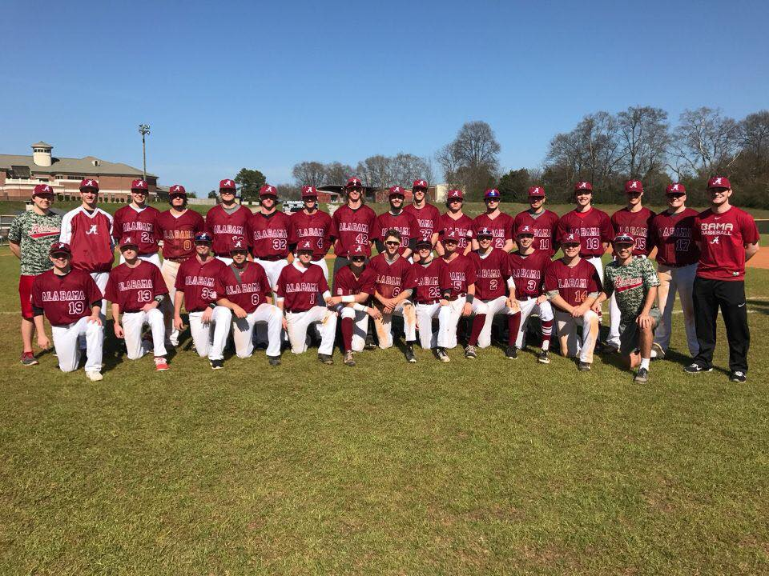
The Alabama club baseball team will take on the University of Tennessee-Chattanooga in a big-time conference tripleheader this weekend. (Credit: Alabama Club Baseball)
By: Parker Baltazar

Tuscaloosa, AL- The Alabama club baseball team begins conference play this weekend as they host conference rival University of Tennessee-Chattanooga in Tuscaloosa. Both teams are looking to notch their first wins of the season and the tripleheader has major conference implications on the line.

The Alabama club baseball team has won the South Atlantic conference in the West division four years in a row dating back to the 2016 season and is on a mission to win their conference for the fifth year straight. The team is healthy and enthusiastic about the season ahead.

“We have an amazing group of guys this year who are committed to win. We’re not a varsity sport but we compete like professionals and play our hearts out every time we take the field,” said senior outfielder Clayton Kellum who is on his fifth year with the team.

Both teams have not started the season as well as they would have liked to (0-3) with Alabama being swept by the University of Georgia and UTC being swept by East Carolina. UTC failed to score a run in their tripleheader against the Pirates and forfeited all three games while giving up 23 runs in the series. They hope to be better prepared to play against the talented squad at Alabama.

The games will be held at the recreational fields at the University of Alabama with the opener on February 8 at 12 P.M. followed by another game at 2 P.M. The final game of the tripleheader will be at 12 P.M. on Sunday, February 8.

Alabama has always prided themselves on their pitching. Pitcher Asher McCallister was just awarded the conference pitcher of the week after keeping Alabama in the game against Georgia with nine strikeouts and just one earned run allowed. Despite his dominant performance however, Alabama did not have the run support to knock off #10 ranked Georgia.

“It’s always an honor to be recognized and I’m glad that I could do what I could to keep the team in the game. However, a loss is a loss and we play to win,” said McCallister when asked about this recognition.

UTC looks to bring more power to the plate and not give up as many runs early in the game. Their pitching struggled against East Carolina and they will have their hands full with threatening Alabama hitters such as catcher Robert Soran. In two games against Georgia, Soran produced 4 RBI’s at the plate, a double, and a home run. A major key to UTC’s success in the series will be their pitching slowing down Alabama’s dangerous bats.

Despite being swept by Georgia, Alabama’s morale remains high heading into conference play. “Georgia was a very tough test to start the season-they’re a great team that just outplayed us last weekend. Hopefully with conference play starting we can really get into the swing of things,” said second baseman and team president Seth Ballew.

The South Atlantic conference consists of Georgia Tech, Ole Miss, Mississippi State, and Kennesaw State along with Alabama and UTC. Alabama has found success in the last four years as conference champions, but UTC consistently gives Alabama a test when they face one another. In the 2018-2019 season, UTC beat Alabama in their tripleheader two games to one in Chattanooga.

UTC was recently promoted from Division II to Division I after their dominant success in the Division II realm. The Mocs won the 2016 Division II World Series Championship and have built a very solid program that competes with high levels of intensity.

Stakes are high in conference play and there are major impacts on the line. If Alabama wishes to repeat for a fifth straight year in conference play, knocking off the Mocs is the first step on their journey. Each team in the South Atlantic conference plays each other once in tripleheaders for 15 games of conference play total. Alabama finished 10-5 in conference play last year and UTC was just behind them with a record of 9-6 in conference play. These two teams are no strangers to vying for the top spot in the conference and a rivalry is blooming between the two teams for the South Atlantic title.

Alabama’s team was unable to practice on Thursday due to inclement weather in Tuscaloosa but the forecast looks promising for the tripleheader. The last time the Mocs visited Tuscaloosa was in the 2017-2018 season where Alabama won the tripleheader two games to one in a season where both teams finished an impressive 13-2 in conference play and with Alabama taking the conference title due to this tiebreaker.

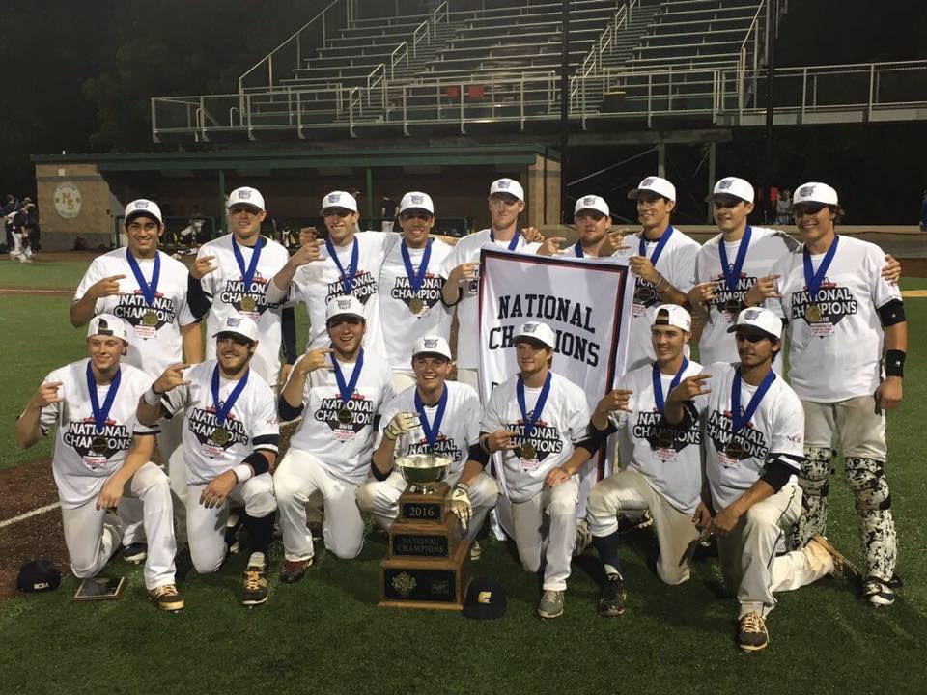
The 2016 University of Tennessee-Chattanooga squad were Division II World Series champions before moving up to Division I and joining Alabama’s conference. (Credit: UTC Blogs)

With major conference implications on the line, it will certainly be a battle between the two teams this weekend. Alabama’s streak of conference championships will be put to the test as the UTC Mocs come into town ready to disrupt Alabama’s recent success and take the conference for themselves.

