All Levels of Baseball Paying a Price Following Astros Scandal
By: Parker Baltazar

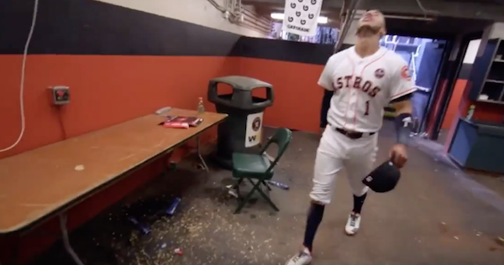
Carlos Correa of the Houston Astros enters the team’s dugout where their controversial setup for sign-stealing allegations was stationed. (Courtesy: New York Post)

A tainted game

Baseball is a game that prides itself on its legacy- “a national pastime” that has been played and loved by Americans for over a century. Recently however, a great stain has come across baseball and its legacy in the shocking cheating allegations against the Houston Astros and their 2017 World Series title. These allegations have rocked baseball to its core and fans, coaches, and players at all levels have been affected by these accusations.

Personally, the news of these allegations sent me into a frenzy of rage. As a passionate fan I asked the following questions: How could this be? How did they get away with it? In what world is their championship valid? Surely the ends do not justify the means here!

The MLB is very shaken up following this and the Astros are in for a long season. Multiple players on the team have already been beamed with pitches and there is a running “shame tour” of the team trending on Twitter. Commissioner of Major League Baseball Rob Manfred has handled the situation in a very lenient way and his actions have infuriated many. In the words of LeBron James, ‘You need to fix this’.

And LeBron does not even play the sport! I can’t even begin to imagine how players feel- especially teams like the Yankees and the Dodgers who lost to the Astros that postseason. A game that prides itself on its fairness and legacy has truly been tainted and the aftershocks of these accusations will surely change the way fans watch and enjoy baseball.

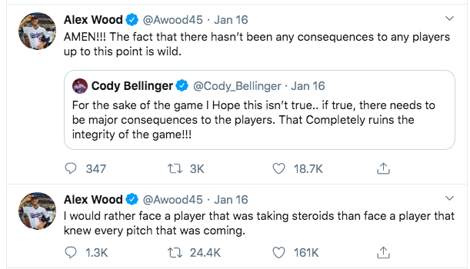
Alex Wood, pitcher for the Los Angeles Dodgers since 2015, voiced his opinions about the Astros scandal on Twitter. (Courtesy: Twitter)

It’s not just the MLB

All levels of baseball are feeling some sort of consequence either directly or indirectly in the aftermath of the accusations. Many members of the Alabama club baseball team expressed their frustration and talked about how their actions have changed the perception of baseball overall.

“It’s just such a bad look for the game,” said catcher Robert Soran of the Crimson Tide. “I always considered baseball to be a game of pride and passion and what [the Astros] did goes totally against that.”

Building on that, shortstop James Moore of the Alabama club added that the allegations “had [him] feeling angry and betrayed by the professional league of the sport [he] loves the most.” This is a sentiment that many fans of the game are feeling, and many fans feel that the consequences were not nearly as severe as they should have been.

“For the Astros to keep their championship and not have to face a sort of death penalty…just seems absolutely ridiculous to me,” said pitcher Grant McCarthy of Alabama’s club squad.

Harsh…but not harsh enough

Major League Baseball suspended Astros’ GM Jeff Luhnow along with manager A.J. Hinch for a year each and the Astros’ received a $5 million fine along with losing all their first and second-round draft picks in both 2020 and ’21. Considering that the Astros are worth approximately $1.8 billion, a five million dollar fine is just a drop in the bucket for the franchise. The Astros’ success also came at the expense of many other teams and their players. Players lost out on proper postseason bonuses and stats for players are not as accurate as they should be due to the Astros’ cheating. The Astros went 8-1 at home in the postseason that year and hit .273 as compared to 3-6 on the road while batting .208. Granted that home-field advantage is a major factor in games, the difference between the Astros at home and on the road that postseason was rather alarming.

Franchises that the Astros defeated also may have lost value as well. Player’s legacies were also affected: take for example Clayton Kershaw of the Los Angeles Dodgers. He has had a narrative of not being able to perform as well in the postseason, and this discussion was again brought up after Kershaw was wacked in Houston in Game 5 of the 2017 World Series.

This is a huge stain on baseball, and many will look upon the Astros along with commissioner Manfred and MLB with disdain. It is certainly going to be a long year for Houston, and they will have their hands full for years to come. Major League Baseball has not had a hot topic of debate rage on like this since the steroid/PED debate. The Astros are not the only team in headlines for the sign-stealing debate as Alex Cora, former manager of the Boston Red Sox, was also accused by The Athletic of Boston having their own sign-stealing scheme. With technology growing as rapidly as it is, who knows what the future of baseball holds with opportunities to cheat like the Astros did?

There were certainly a plethora of organizations and players affected and the consequences of the Astros’ actions will affect not only Houston and the rest of the league for years to come but will also have a devastating impact on the game of baseball. A sport that has been loved by Americans since the 19th century now has a massive stain on it and fans and players alike are left feeling both confused and betrayed. We can only hope for the future that the game’s legacy remains intact as a sport of integrity, fairness, and enjoyment for fans everywhere.

