No Dancing This March as COVID-19’s Impact Continues to Devastate Sports
By: Parker Baltazar

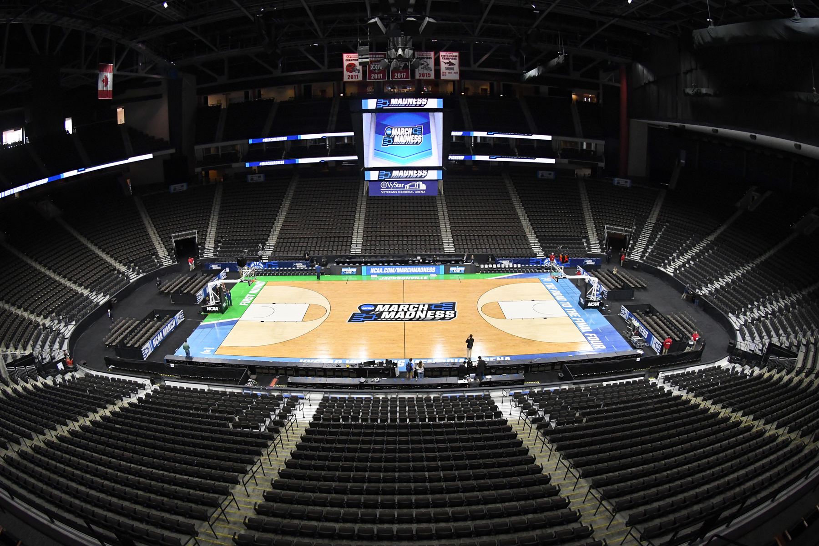
The 2020 NCAA Men’s & Women’s Basketball Tournaments were canceled on March 12 in response to the COVID-19 pandemic (photo courtesy of Rolling Stone).

March Sadness

There will be no Cinderella stories to be had this March. No nets will be cut down, and no brackets will be busted. No bubbles will be popped, and no buzzers will be beaten. Amongst growing fears over the COVID-19 pandemic, the NCAA announced that the Men’s and Women’s College Basketball Tournaments would be canceled on March 12, 2020. This is the first time that the tournament has been canceled since its inception in 1939.

COVID-19 has devastated many aspects of life across our globe, and sports were not immune to the wrath of the virus. Many could say that they had seen this coming. Just a few days before the NCAA’s announcement to not hold the 68-school tournament field, major conferences canceled their conference tournaments one after another. The NBA suspended their season indefinitely after center Rudy Gobert of the Utah Jazz tested positive for the virus. European basketball leagues followed suit and suspended play with postponements and cancellations.

Paul Brazeau, a senior associate commissioner for men’s basketball in the Atlantic Coast Conference, said that it was really only a matter of time before the NCAA tournament was canceled for the 2019-2020 season.

“When you see how telling the statistics are for the virus and considering how rapidly it has spread, there was just no way it could have been possible. As devastating as not having the tournament is, it just wouldn’t have been safe at all,” said Brazeau.

The Selection Sunday That Never Came

Selection Sunday was slated to be on March 17, 2020. The NCAA had been nearly completed with its basketball season when the announcement to cancel the legendary tournament was made just five days before this fateful Sunday. Many teams had the opportunity to improve their resumes before the tournament in their respective conferences, and major ‘bubble’ implications were on the line.

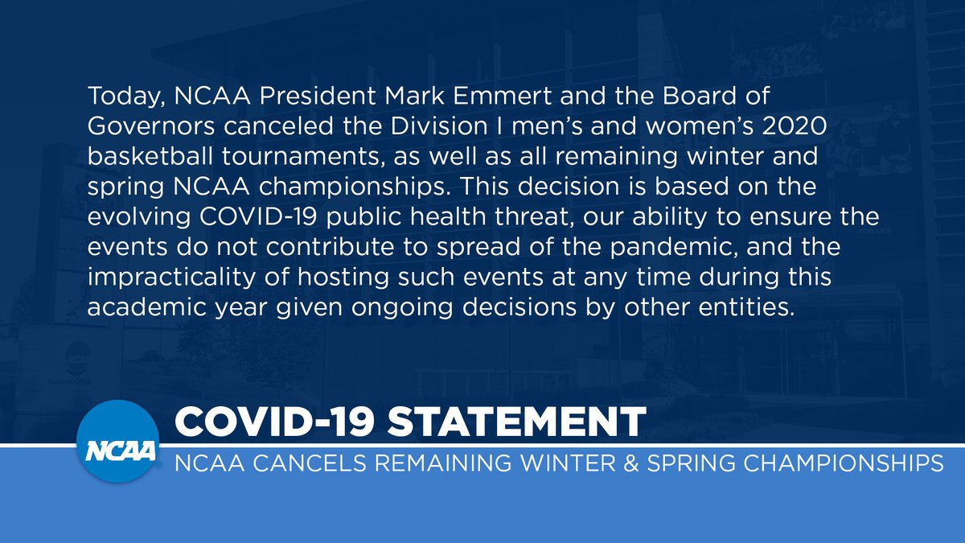
The NCAA’s statement on COVID-19 to cancel the Division I men’s and women’s 2020 basketball tournaments (credit: @NCAA via Twitter).

Gonzaga, Villanova, Virginia and Baylor were the projected number one ranked seeds according to Joe Lunardi’s Bracketology. Nine teams were projected to represent the Big Ten Conference and seven teams each from the Big 12 and the ACC conferences, respectively. Teams such as Memphis, Marquette, and Syracuse were set to battle hard in their conference tournaments to earn the last few spots up for grabs in the NCAA tournament. The Final Four and National Championship were supposed to be held for the first time at Mercedes Benz Stadium in Atlanta on April 4 and April 6.

NCAA March Madness is one of the most famous annual sporting events in the United States and is enjoyed by millions of Americans. It is truly a wild period for basketball fans, and it really has an influence on all sorts of fans across America. Tens of millions of people fill out their bracket predictions, fans from all over stream the 63 games live, and the tournament even renders office workers productivity negatively for three weeks.

This is the first time that the tournament has been canceled since it was created in 1939. March Madness has grown to become one of the most exciting times of the year for sports fans. From commercials to office banter, it is really all that sports fans everywhere see and hear about for weeks at a time. COVID-19 has had crippling effects on the world, including the sports industry, and March Madness was just one of the many major sporting events that faced the shocking effects. The tournament has significant cultural implications all across America, and fans of college basketball are devastated. People spend almost their entire days watching the first round with seemingly nonstop action, including 32 games in just two days.

“It’s a cultural phenomenon of sorts. Talk about the tournament seems to take over conversations and brings people from all across the country together. It’s something that everyone seems to bond over whether you’re in an office or out at a bar,” said Carmen Maciariello, head men’s basketball coach at Siena College.

Maciariello would know a thing or two about the impact of the NCAA Tournament being canceled. His squad at Siena was on quite the hot streak, winning ten games in a row along with the MAAC regular-season championship heading into the MAAC tournament semifinals. His team was one of the bubble teams that was projected to make the tournament as a #15 seed, according to Joe Lunardi. Now, however, he will not know what would have become of his team.

“It’s just sad to see because these guys really worked so hard all year to lead up to the tournament. Now I guess we’ll never know,” added Maciariello.

Don’t You Miss Basketball?

Basketball has been affected by the impacts of the coronavirus on the amateur, collegiate, local, and professional levels internationally. The NBA, along with several international leagues, have suspended their seasons indefinitely, and the chances of their seasons returning are up in the air. Conference tournaments and March Madness were canceled just a few days after the NBA’s announcement. The 2020 Summer Olympic Games were postponed, and international fans of basketball will have to wait until 2021 to see countries battle one another for the Olympic gold medal. On a local level, parks have removed rims in cities’ efforts to enforce social distancing. However, in optimistic news, the NBA has declared that on May 1, practice facilities could reopen where local governments have eased stay-at-home orders.

At first, there were talks about holding the NCAA Division I Tournament games in arenas without fans. The Division III basketball tournament was initially held without fans, and the NCAA believed that this could be a possible alternative to go on with March Madness. Yeshiva University beat Worchester Polytechnic with a 102-78 win in a gymnasium at Johns Hopkins University that consisted of an attendance of zero. Strictly players, coaches, referees, employees, and media members were present. The game was initially delayed by more than an hour, as Yeshiva needed to provide medical documentation that ensured that they were safe to play.
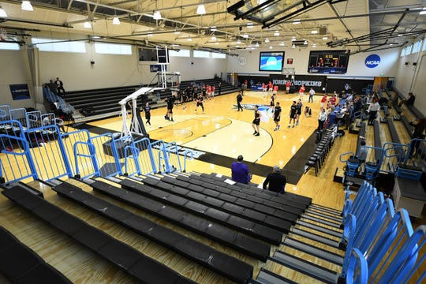
Yeshiva University warms up in a practically empty Goldfarb Gymnasium at Johns Hopkins University prior to their first-round game in the NCAA Division III tournament (photo courtesy of The Detroit News).

This game however, was before many knew how serious the impacts of the coronavirus would affect sports and daily life in America. An NCAA COVID-19 advisory panel said on March 6 that they were “not recommending cancellation or public spacing of athletic and related events scheduled to occur in public spaces across the United States.” Their panel thought differently just six days later when they canceled the Division I Tournaments.

A Virus That Hits Hard

The coronavirus pandemic has shaken the world and the sports industry to its core. America’s economy has been rocked by COVID-19, and the loss of major events has affected the world of sports tremendously. For example, March Madness makes the NCAA the most money as compared to any other event that college athletes compete in. From television and marketing rights alone, the NCAA made $867.5 million from just March Madness in the 2018-2019 fiscal year. The next year, that figure was up to nearly $1 billion with ad revenues of $933 million.

The event is absolutely colossal and held dear to basketball fans all across America. The NCAA Tournament, spanning across 14 cities and dominating sports headlines for weeks, has become a staple of sports in America with fans feeling eager all year to get into the madness of college basketball that is March. Between conversation, media advertisements and promotions, and the thrill of making a bracket, Americans are troubled to not be able to experience March Madness this year.

“March is normally one of my favorite times of the year with the NBA heating up and conference tournaments and March Madness just getting underway. It’s unfortunate to see the impact that this virus has had on sports and on basketball, especially at such an exciting time of the year for the sport,” said Archbishop Stepinac High School basketball coach and basketball guru Patrick Massaroni.

The 2021 NCAA Men’s Basketball Tournament is scheduled to begin on March 21, 2021, and conclude with the national championship game on April 5, 2021, at Lucas Oil Stadium in Indianapolis. The future of basketball remains up in the air as the coronavirus continues to threaten the world. However, one could believe that fans will be ecstatic for the return of college basketball and March Madness next year. Many teams may feel that they had the opportunity for a championship run taken away from them. It will undoubtedly be interesting to see how these schools will come out and perform when college basketball does eventually return.

March Madness was not immune to the impacts that coronavirus had on sports. As such, basketball enthusiasts can only predict how the NCAA’s postseason would have played out. The cultural phenomenon of March Madness and its cancellation has a detrimental impact on sports business, and fans are crushed to have a March with no NCAA tournament. The Cinderella stories will have to wait.

